DM LAB02 report
Student information
- Name: 潘怡璇
- Student ID: 112034575
- GitHub ID: c24668343
- Kaggle name: yeexuan pan
- Kaggle private scoreboard snapshot

Overview
My project implements a BERT-based text classification pipeline to predict emotions from textual data. The emotions include eight classes: anger, anticipation, disgust, fear, joy, sadness, surprise, and trust. I will explain these process I adopt involves data preprocessing, feature engineering, model training, evaluation, and prediction.

- Preprocessing Steps
  - Data Loading
First, I load the JSON file into a dataframe and export it to CSV files. Then, I load the training (train.csv) and test (test.csv) datasets. Each dataset contains a column for textual input and its corresponding emotion label.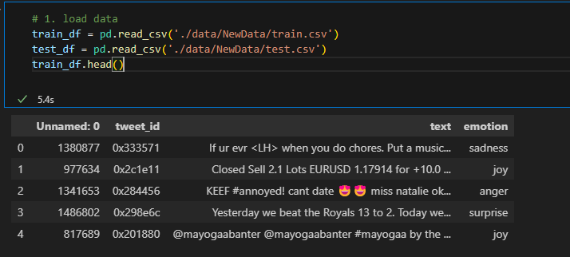
  - Label Encoding
The categorical emotion labels in the training data are converted into numerical values using LabelEncoder. And I create a dictionary, mylabels, that maps emotion names to integers to facilitate interpretation.
  - Dataset Splitting
To evaluate model performance during training, I split the training data into 80% training and 20% validation sets.

- Feature Engineering
  - Tokenization
The textual data is tokenized using BertTokenizer. This step transforms the input text into tokens that are compatible with the BERT model.
- Parameters：
max_length=40: Ensures all tokenized sequences are of equal length (padded or truncated as needed).
return_tensors='pt': Returns data in PyTorch tensor format for compatibility with the model.
  - Dataset Preparation
A custom TextClassificationDataset class extends torch.utils.data.Dataset. It stores tokenized texts, labels, and handles data retrieval via indexing. And
it ensures consistent formatting of inputs (input_ids, attention_mask) for BERT.
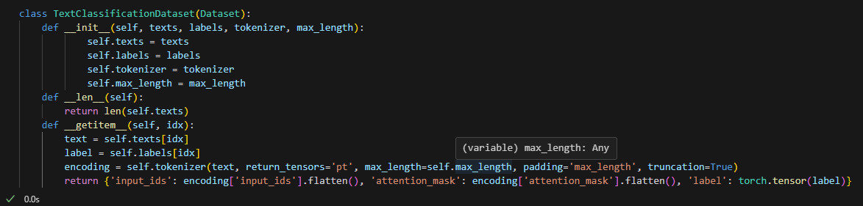
  - Dataloader
DataLoader is used to create batches for both training and validation datasets, ensuring efficient data handling during model training.

- Model Explanation
  - BERTClassifier
I utilize PyTorch-based classifier that leverages a pre-trained BERT model (bert-base-uncased) for feature extraction.
- Architecture:
- BERT Backbone: Extracts contextual embeddings from input tokens.
- Dropout Layer: Reduces overfitting by randomly setting some activations to zero during training.
- Fully Connected Layer: Maps the embeddings to eight output classes corresponding to emotion labels.
- Outputs:
- Logits for each class, which are converted to probabilities using CrossEntropyLoss.
  - Loss Function
I use CrossEntropyLoss to compute the loss by comparing predicted logits with true labels.
  - Optimizer and Scheduler
Optimizer: AdamW is used for efficient weight updates with a learning rate of 2e-5.
Scheduler: get_linear_schedule_with_warmup adjusts the learning rate during training, helping the model converge smoothly.
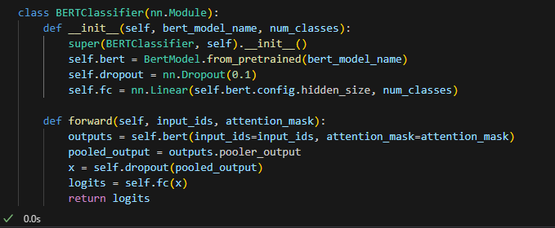
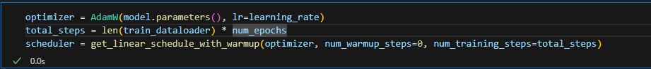

- Training and Evaluation
  - Training Loop
Each epoch involves:
  - Forward pass: The model processes input batches and computes predictions.
  - Backward pass: Gradients are calculated and parameters are updated.
  - Learning rate adjustment: The scheduler fine-tunes the learning rate.
  - Evaluation
After each epoch, the model's performance is evaluated on the validation set.
Metrics:
- Accuracy: Proportion of correct predictions.
- Classification Report: Includes precision, recall, and F1-score for each class.
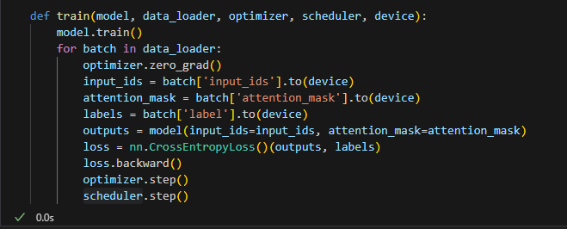
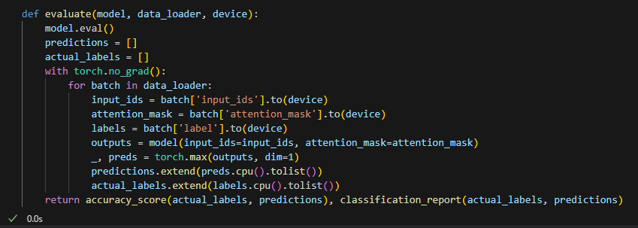
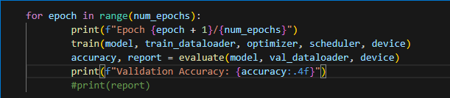
- Prediction and Output
  - Prediction Function
The predict_sentiment function processes individual text samples:
- Tokenizes input text.
- Computes class logits using the trained model.
- Maps the predicted label index back to the corresponding emotion using mylabels.
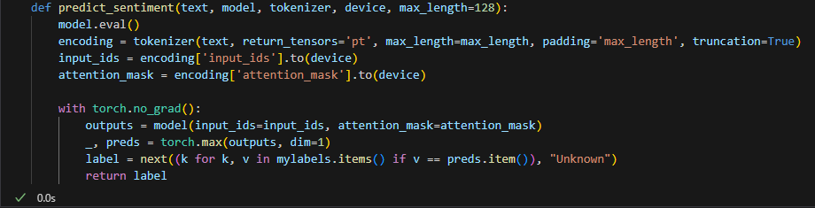
  - Test Set Predictions
The test dataset is processed row-wise, and predicted emotions are stored in a new column, predicted_emotion.
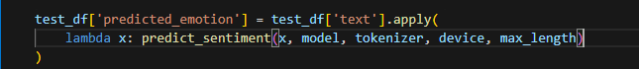
  - Output File
The predictions are saved in a CSV file (bert_classifier_v2.csv) with two columns:
- id: Tweet ID from the test dataset.
- emotion: Predicted emotion.

